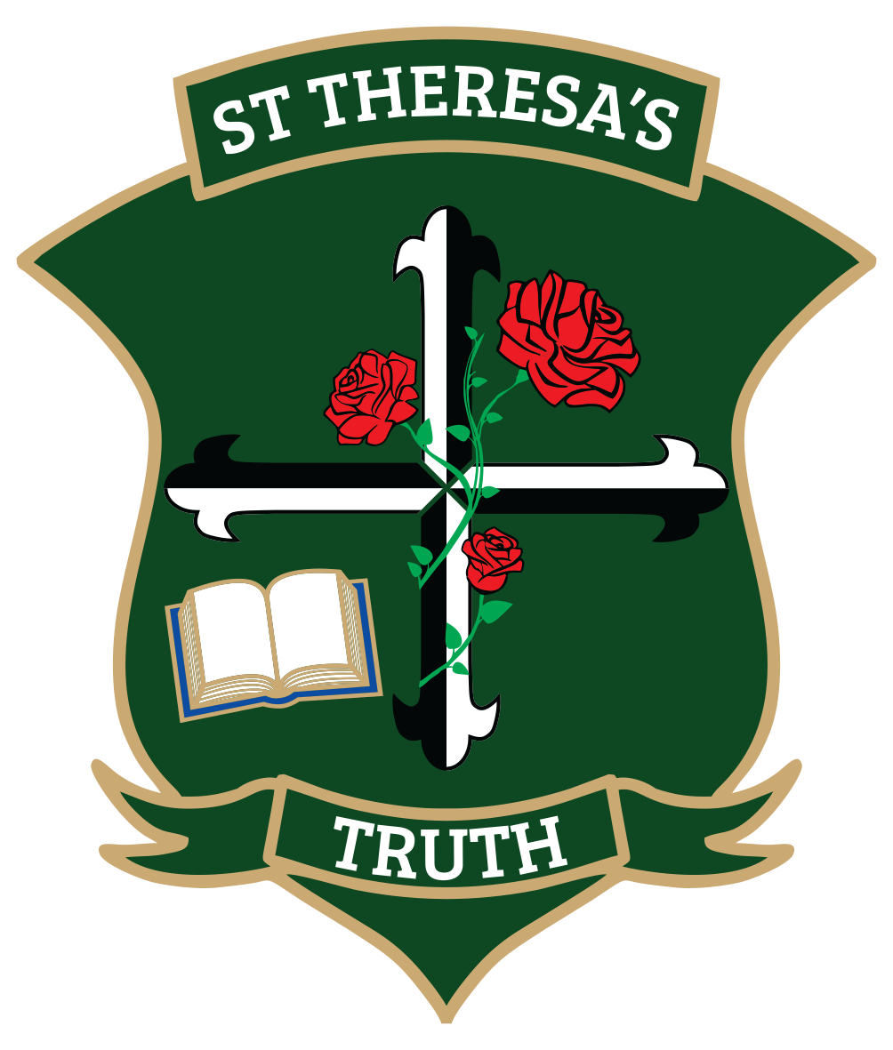

ST THERESA’S SCHOOL

PRIVACY POLICY

RATIONALE
The Board of Trustees is required to comply with the provisions of the Privacy Act 2020 in all aspects. St Theresa’s School will respect the privacy of all individuals.

References:
Privacy Act, 2020; Education Act, 1990; Education Amendment Act, 1993; Archives Act, Privacy in Schools 2009, published by The Privacy Commissioner, Official Information Act.

PURPOSE
- To promote and protect individual privacy with regards to the collection, use and disclosure of information relating to individuals.
- To guide access by each individual to information relating to that information held by the school.

DEFINITION
The 13 Privacy Principles:
- Only collect identifying information that you need
- Get the information from the individual concerned
- Tell the individual you are doing it
- Use lawful, fair and reasonable methods to do it, particularly regarding children’s and young person’s information
- Store and transmit information securely
- Give people access to their information
- Dealing with incorrect personal information
- Checking for accuracy before use
- Retaining information only for as long as necessary
- Use personal information for its purposes
- Limits on disclosure of personal information
- Protecting personal information when disclosed outside of New Zealand
- Take reasonable steps to protect unique identifiers from being misused.

- Privacy procedures will be developed and will comply with the Privacy Act and it’s principles as listed above.

- We will comply with all requirements of the Act, including notification to the Commissioner of any breach. We will use the Notify Us tool to identify if there is a potential notifiable breach at: privacy.org.nz/responsibilities/privacy-breaches/notify-us.

- The following tells you how we will use and safeguard the personal information you provide us on our website. By visiting our website you agree to this privacy notice.

- The Board acknowledges the right of individuals to change any information held about them if it is shown that the stored information is incorrect.

- Each individual may request access to any information about them which is stored by the school. It will be provided in a timely manner.

- All forms used for the collection of personal information such as enrolment forms, will be noted with a clause that advises individuals about the collection, storage, use and access to information. E.g. This information is gathered for the purposes of furthering the education of your child. It will be used within the school and as statistical information when required by the Ministry of Education. In completing such official requests individual students are not identified. You have the right to alter, amend and view any of these details at any time while your child attends St Theresa’s School.

- Permission is sought on our school enrolment from parents or caregivers for use of photographs, name and examples of their learning used in both electronic and printed form (school website, newsletters, newspaper). Where permission is not sought, photographs, names and work of the student concerned will not be used without permission from parents or caregivers.

- We will not share email addresses with others. This means that all group emails such as that used to send out the weekly school newsletter will be blind copied so that no one is able to identify who the recipients are or access their email address.

- Where an individual believes their privacy to have been breached, or where the school takes any action that may possibly be considered a breach of privacy, the school will advise the individual of their right to make a complaint to the Privacy commissioner.

- Information regarding the number of views the site has each month, where the views are coming from and any key word searches being used to find our Site will be collected.

- We will collect, use and retain information about you only if we believe it is justified, required and useful in order to conduct our transactions with you effectively and to provide you with the service you have requested.

- We may disclose personal data in order to comply with a legal or regulatory obligation.

- We will not use any information provided by you to contact you for any other purpose than the service you have requested.

- We will not share your information with any other parties except as it pertains to the service you have requested.

REVISION OF PRIVACY POLICY
St Theresa’s School reserves the right to change, modify or revise this policy in order to comply with any applicable laws or for any other reason at any time. Therefore, users are required to check the Privacy Policy regularly to read about any changes or revisions. You will be deemed to have consented to the changes by your ongoing use of the site following any changes.

CONCLUSION
Protecting your privacy is important to us. Therefore the school will abide by the 13 privacy principles, ensuring that each individual’s right to privacy is protected.

Formulated: 1 December 2020

Approved: May 2024

Reviewed / Ratified: Triennially, May 2027

